Venue
Venue:
Medicaps University
A.B. Road, Pigdamber, Rau, Indore-453331, M.P., India
+91-731-3111500 | +91-731-3111501
ic4@medicaps.ac.in

Co-Venue:
Aivancity School of AI and Data for Business and Society
151, Boulevard Maxime Gorki, Villejuif, France
Phone: +33 (0) 1 88 38 03 00

************************
IEEE France Section

Dr. Florence Sedes
President, IEEE France Section
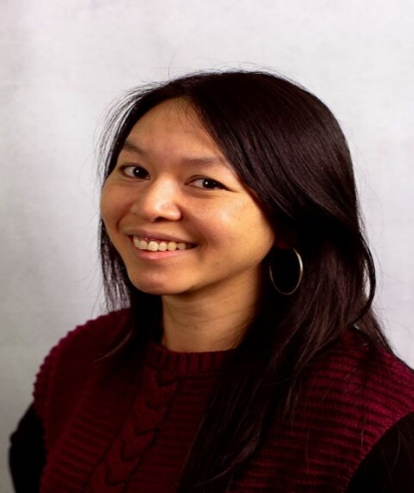
Dr. Marina Deng
Vice President, Conferences, IEEE France Section

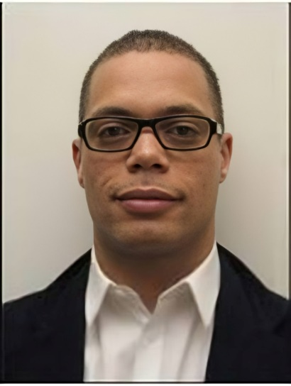
Adrien Revault d'Allonnes
President, Computational Intelligence Society, IEEE France Section


Roua Touihri
President, Computer Society, IEEE France Section


Pascal Lorenz
President, Communications Society, IEEE France Section


Gérard-André Capolino
President, Power Electronics Society, IEEE France Section

